Game Design Document

Fill up the following document

1. Write the title of your project.

Shoot the Asteroid!

1. What is the goal of the game?

The goal of the project is to shoot the asteroids that’s headed towards Earth and keep Earth protected

1. Write a brief story of your game.

Jarvis told himself that he will always protect earth from celestial bodies with his extraordinary skills and knowledge on Space ships and Astronomy. In this game he will use his SpaceX-Pro to destroy all asteroids from the Asteroid belts which will come towards Earth.

1. Which are the playing characters of this game?

* Playing characters are the ones who respond to the user based on the input from the user.
* Cars, monkeys, dinos, wizards, etc., are the playing characters in the game.

|  |  |  |
| --- | --- | --- |
| Number | Character Name | What can this character do? |
| 1 | Jarvis | Main character of the game who will control the spaceship |
| 2 | Space ship | This character has the capability of destroying the spaceships |
| 3 |  | This is a NPC that will be generated randomly and attack the space ships |
| 4 |  |  |
| 5 |  |  |
| 6 |  |  |
| 7 |  |  |
| 8 |  |  |

1. Which are the Non-Playing Characters of this game?

* Non-Playing characters are the ones that don't have an action or behavior when the user interacts with the game.
* Hurdles, stones, bananas, coins, etc., are non-playing characters in the game.

|  |  |  |
| --- | --- | --- |
| Number | Character Name | What can this character do? |
| 1 | Asteroids | This is a NPC that will be generated randomly and attack the space ships |
| 2 |  |  |
| 3 |  |  |
| 4 |  |  |
| 5 |  |  |
| 6 |  |  |
| 7 |  |  |
| 8 |  |  |

Draw your imagination of this game. What does this game look like?

* Draw the game either on your computer or on paper.
* Add images of the game scenes to show each of the playing and non-playing characters at least once.

(Note: This is just a glimpse of the game many things will be changed)

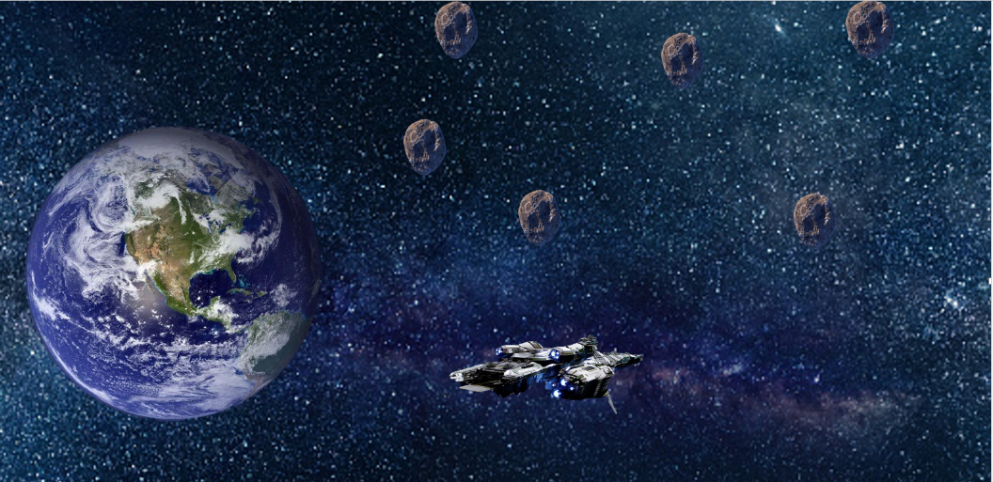

How do you plan to make your game engaging?

I plan to add different sort of effects and a more real life controller not like the usual control of the space ship with arrow keys but different buttons to make it look better and there will be equal amount of chance and skill as well as adaptivity which will increase over time as game progresses.